GROW Logo MoNE Logo Canada Logo CWS



Contact Us

(For the designer: can we include a photo before /or after the menu – that could have a slideshow capacity (changes regularly, and we could include videos if we want? Similar to this website: http://www.competeproject.ps/index.php)?)
Who we Are? | GROW Components | Become a Beneficiary | Resources | Media | Announcements
About GROW  Implementing Agency & Partners  Donor  Meet our Team | Component 1: Supportive Environment for Women-led MSMEs  Component 2: Technical, Business and Managerial Capacity Building  Component 3: Supporting the Adoption of Renewable Energy | Key Principles  Vulnerability Criteria  Entrepreneurship Criteria  Baseline Assessment | Studies  Policy Briefs  Infographics  Brochures  Her Voice | Calendar of events  Photo Gallery  Video Gallery  Press Releases and Articles  Radio Interviews and Spots | Applications  Procurement  Recruitment

Who We Are?
About GROW
Undertaken with the financial support of the Government of Canada (link to their website https://www.international.gc.ca/gac-amc/index.aspx?lang=eng) provided through Global Affairs Canada (GAC), and in cooperation with the Ministry of National Economy, GROW is four-and-a-half-year project (2018-2022) that aims to enhance economic empowerment and increase prosperity for low-income women and youth in the West Bank. The project responds to the development needs and challenges faced by female entrepreneurs in the West Bank, to move beyond their essential but largely unrecognized roles, ultimately contributing to their increased voice and agency in both social and economic spheres, while enhancing the overall productivity and competitiveness of the target value chains within the agribusiness subsector.
Anticipated Results
GROW will focus on three inter-related intermediate outcomes:
- Reduced barriers to entrepreneurship faced by women
- Enhanced opportunities for women entrepreneurs to successfully establish and/or grow sustainable businesses; and,
- Enhanced opportunities for female entrepreneurs, particularly female youth, to support the adoption of renewable energy in the olive, goat and sheep dairy and agri-food processing value chains.
To achieve these outcomes, the project will address several key challenges impacting women’s entrepreneurship in the West Bank, including the prevalence of socio-cultural barriers and their associated impacts on women’s household, community, and economic roles and status; and, women’s limited access to finance, business development support services, technology, reliable and affordable energy, skills development opportunities, and markets.
Our Approach
GROW is designed to respond to Global Affairs Canada’s objectives and aims to be an innovative, evidence-driven project that places a priority on identifying activities and entry points in targeted value chains that respond to supporting women’s economic empowerment (WEE). The designed activities take into consideration constraints and barriers faced by women due to the market structure and those related to the social system and cultural norms. Hence the project activities are two pronged: 1) those activities aiming to improve women’s access to opportunities, competitivess, and position within value chains and sub-sectors, and consequently income; and, 2) those activities aiming to address social system’s constraints to improve women‘s agency (voice, choice, and decision making powers at the household and community levels)
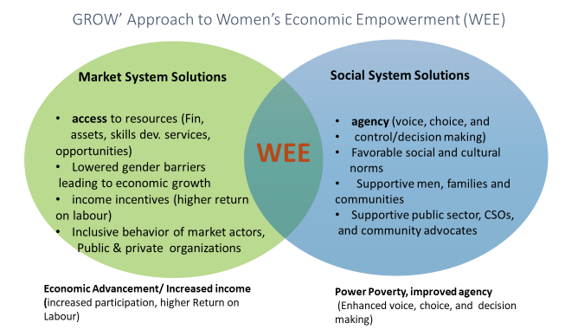
To do that, GROW will maintain to the extent possible, a market systems lens and will build partnerships with market actors at community, district, and national levels to ensure market actors change behavior and adopt new practices that are more gender equitable and sustainable and simultaneously, equip women with needed skills and capacities to effectively engage in markets.

GROW’s approach recognizes that poverty is multi-dimensional. Monetary and agency poverty shape the degree to which women can participate socially, politically and economically. Hence, an inclusive approach to targeting different profiles of poor women has been designed in close collaboration with GROW’s partners. Women will experience different paths to empowerment based on the social and economic dynamics in their households and communities. Some women may advance economically and increase their income as a result of improving their skills and productivity and access to needed services which will lead to an increase in their incomes. Other women may experience improved agency levels as a result of improved awareness of their rights, access to support networks, and/or enhanced familial and community support. While others may experience different levels of advancement on both the income and agency levels. This approach will generate varied and unique learning and knowledge sharing opportunities. Working in traditional and non-traditional sub-sectors and value chains with different types of enterprises (women MSMEs in the agro-food processing, sheep and goat dairy, olive by-products value chains) and men-led enterprises in the case of Renewable Energy, to change their behavior to be gender equitable and inclusive of women in their recruitment and employment policies and practices, whilst targeting different profiles of women (above 30 years, married with children in the case of Agro-food VC, and female youth under 30 years in the case of Renewable Energy), provides an exceptional platform for a set of diverse activities that will have different dynamics, challenges, and opportunities.
As part of its management approach GROW will ensure that the project creates a platform for innovative design, implementation, learning, and adaptation. The following are the broad categories that GROW will base an inclusive portfolio upon in both elements (social system and market system) of intervention design and implementation to ensure continued project diversification and inclusiveness.
- Sectors – ensuring working in sectors where large numbers of poor and low-income women are already engaged as well as sectors where women need to be introduced to (such as Renewable Energy).
- Women Profiles – ensuring women from diverse social and economic backgrounds are engaged as target beneficiaries, service providers, and role models.
- Intervention Types – leveraging diverse activities such as facilitation, skills development, coaching and mentoring, apprenticeships, grants, procurement, and maket linkages.
- Formal and Informal – engaging with women in both formal and informal sectors and facilitating the formalization of their businesses.
- Private Sector – working with different types of companies to create linkages with women enterprises and facilitate access to high value employment opportunities for skilled educated women (RE),and incentivize private sector companies’ to change behavior to be more inclusive of women.
- Rural and urban – GROW will target poor and low income women who mostly reside in rural and marginalized areas, but will also ensure diversity and inclusion of women who are income and agency poor. GROW will not exclude women from urban areas (such as educated unemployed women who are both income and agency poor). Urban areas with higher disposable incomes are more lucrative markets for rural women’s products, and so facilitating market access to urban settings is one of the project’s priorities.
- Value Chain upgrading – moving women along value chains into new positions and activities, such as product and market channel upgrading.
- Education – working with women beneficiaries from diverse education levels.
- Partners – working with a broad range partners and duty bearers (e.g. public, private, CSOs, cooperatives, syndicates, private sector representative bodies such as chambers of commerce and PalTrade) to facilitate behavior change to become more inclusive and gender equitable in their policies, practices and service delivery. NGOs focusing on people with disabilities to ensure women with disabilities are aware of the project can take part in the beneficiary outreach activities.
- Other Donor programs – Coordination to avoid overlaps, identify potential areas for synergies and complementarities.

Implementing Agency and Partners
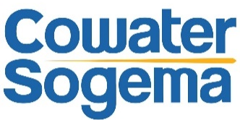
CowaterSogema (link to their website www.cowatersogema.com) is the leading implementing agency and responsible for project management, delivery of results and financial control. With over 800 projects implemented in more than 80 countries, CowaterSogema is a global leader in management consulting services, focusing on developing and emerging economies. We work with governments, partner organizations, communities and civil society to design and implement sustainable solutions that generate lasting social, financial and environmental impacts. As Canada’s largest international development consulting firm, CowaterSogema has developed a reputation of excellence for our strong ability to work with clients and stakeholders to provide leading-edge solutions and services tailored to the needs and challenges faced by developing and transitional countries. Our firm possesses internationally recognized and award-winning experience at the policy, program and project levels, developing and managing major projects as well as undertaking studies, sector reviews, evaluations, and training and communications activities.
CowaterSogema is a global company with its headquarters in Ottawa, Canada, an office in Montreal, Canada, an office in Pretoria, South Africa (CowaterSogema South Africa) and operations in Paris, France (CowaterSogema Europe). Additionally, the company currently operates project offices worldwide including in Burkina Faso, Mali, Malawi, Cameroon, South Sudan, Mozambique, Zambia, Bangladesh, Vietnam, Indonesia, Jordan, Peru, Honduras, Barbados, the West Bank, etc.
Our Partners
GROW is implemented in cooperation with the Ministry of National Economy (MoNE) (link to their website www.mne.gov.ps ) and in partnership with Near East Foundation (NEF) (Link to their website www.neareast.org) and the Palestinian Businesswomen Association (Asala) (link to their website www.asala-pal.org)
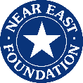
Near East Foundation (NEF) is an international organization that helps build more sustainable, prosperous, and inclusive communities in the Middle East and Africa through education, community organizing, women's empowerment and economic development.
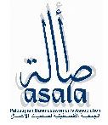
Palestinian Businesswomen Association (Asala) provides comprehensive and needs-based services to marginalized Palestinian women along three strategic tracks, namely: Advocacy and lobbying for women’s economic and social rights, Capacity building for women entrepreneurs, and facilitating access to local, regional and global markets for women entrepreneurs.
(we might add other logos and partners..is this possible?)
Donor
GROW Project is undertaken with the financial support of the Government of Canada (link to their website https://www.international.gc.ca/gac-amc/index.aspx?lang=eng) provided through Global Affairs Canada (GAC).
Canadian foreign policy and its objectives in the Middle East are the foundation for Canada’s development programming and have been since the signing of the Oslo peace agreements in 1993 and the creation of the Palestinian Authority a year later. Canada’s development assistance for the West Bank and Gaza contributes to the achievement of a comprehensive peace agreement negotiated directly by parties that leads to the creation of a viable, independent and democratic Palestinian state.

Meet our Team (still to be developed – we will share with you team photos and a short bio for each one in a separate email)
PHOTO
Name and position below
Safa’ Abdel Rahman-Madi
Team Leader

(If this could be a display of photos with name and position below and when the user click on the photo a description appears.)

GROW’s Components
Component 1: Supportive Environment for Women-led MSMEs
(We will send you later a short description about this component and its underlying interventions)
Policy advocacy and community awareness campaigns
(We will send you later a short description about this)
Chamber of Commerce Campaign 1
(We will send you later a short description about this campaign and the clickable icons on deliverables which will be also in resources. But there will be other campaigns like this)

Campaign 2
(We will send you later a short description about this campaign and the clickable icons on deliverables which will be also in resources. But there will be other campaigns like this)

Campaign 3
Same comments above

Campaign 4

Same comments above

Gender-responsive financial literacy training and access to finance
(Short description about this)
Domestic, regional, and/or international market opportunities.
(Short description about this)
Networking/knowledge-sharing events
(Short description about this)
Component 2: Technical, Business and Managerial Capacity Building
(same comments above)
Entrepreneurship, technical and business management training
(Short description about this)
Training and technical assistance in the development and implementation of sustainable, climate-smart business plans.
(Short description about this)
Technical training on climate smart processing techniques, food safety & hygiene, and innovative marketing provided to women-led MSMEs and cooperatives
(Short description about this)
Gender-responsive business and technical training and start-up support to establish and run school canteen micro-franchises.
(Short description about this)
Component 3: Supporting the Adoption of Renewable Energy
(same comments above)
Awareness-raising campaigns on potential business/job opportunities in renewable energy
(Short description about this - conducted with youth, particularly female youth,)
Sustainable renewable energy-related employment and skills development opportunities
(Short description about this - for women and female youth apprentices or trainees including students and/or recent graduates)
Renewable Energy Innovation Fund
(Short description about this)
Solar Panels Installation and Energy Saving Equipment for MSMEs
(Short description about this)

Become a Beneficiary
Targeting the governorates of Hebron, Jenin, Nablus, Tulkarem, Ramallah (surrounding villages), Salfit and Bethlehem, GROW will directly benefit 3,495 women and female youth, as well as anticipated intermediaries reaching 30,788 individuals (women, female and male youth and men engaged in community awareness sessions, market actors, decision makers, and community members at national and local level).
If it’s possible to add a GIS Map (to use it to show our number of beneficiaries reached based on governorates targeted)
Key Principles
GROW acknowledges that a key success factor will be the ability to operate within a portfolio of interventions that maximizes beneficiary diversity and inclusion. GROW takes into consideration the following key considerations when defining its “target beneficiaries”:
- Defining low-income and marginalization in a context specific way. GROW defines its target beneficiaries in a way that encompasses women and girls, who can realistically be impacted by GROW’s interventions, and that captures the complex nature of economic empowerment and prosperity, including increased income and improved agency (enhanced voice, choice and decision-making) in both economic and social spheres.
- Considering the targeted value chains: The Project will focus specifically on olive by-products, sheep and goat dairy, and agro-food processing value chains, where significant potential exists to empower women, including female youth, to move beyond their essential, but largely unrecognized roles, ultimately contributing to their increased agency in both economic and social spheres.
- Age consideration: GROW targets female youth (18 years and older) and women (18-29 years old).
- Considering targeting vulnerable communities in the targeted governorates. GROW’s outreach approach will focus on the targeted governorates of Hebron, Jenin, Nablus, Tulkarem, Ramallah (surrounding villages), Salfit and Bethlehem. GROW’s beneficiary selection criteria and process will focus on targeting the most vulnerable communities in these governorates, to include Area C and the seam zone areas/close to the wall, residential marginalized areas and neighbourhoods within cities, Bedouin communities, refugee camps, rural and remote areas away from urban areas. The population in these communities often suffer from higher poverty and unemployment rates, violence, as well as lack of adequate services.
- Targeting new and existing female entrepreneurs. To ensure the project is responsive to the often-changing dynamics of women and youth entrepreneurs, GROW will include new and existing female entrepreneurs. New entrepreneurs/MSMEs are women and female youth, who run their own businesses, either individually or with a group of women, within a family, or within a cooperative, or a civil society project since more than one year. Their products are seasonal and are limited to two products. Existing entrepreneurs/MSMEs on the other hand, have businesses that were established for more than one year, and produce more than two products, whether seasonal or all year long.
- Adhering to the targeted value chain/sub-sectors: GROW targets beneficiaries working in goat and sheep dairy, agri-food processing and olive by-products value chains, or have new business idea related to these value chain and in the renewable energy sector.
Vulnerability Criteria
GROW’s vulnerability selection criteria were based on national evidence from several studies, reports and cross-sectoral national strategies, to namely include the:
- Common Country Analysis of 2016 published by the United Nations Country Team and entitled “Leave No One Behind: A Perspective on Vulnerability and Structural Disadvantage”.
- UNFPA’s “Analytical Study: Status of Vulnerable and Marginalized Youth Groups”, published in December 2016.
- National Sectoral Social Development Strategy (2017-2022), published by the Ministry of Social Development (MoSD) in February 2017.
- National Cross-Sectoral Gender Equality and Women Empowerment Strategy (2017-2022), published by the Ministry of Women Affairs (MoWA) in 2017.
- Poverty Profile and the Labor Force Survey, published by the Palestinian Central Bureau of Statistics (PCBS) in 2017.
- GROW Gender Equality Strategy (GES) prepared in 2018.
GROW adopts MoSD’s and United Nations Country Team’s definition of vulnerability that refers to individuals’ or groups’ prospects of erosion in their choices and capacities or their development gains. Being vulnerable is highly interlinked with political and socio-economic drivers that influence a group’s or individual’s ability to adequately access resources, make decisions or socially interact, resulting in unemployment, poverty, violence (political and gender based violence), negative social discrimination, school dropout, negative behavioral practices, weak social and political participation. These trends can negatively impact the life of these groups and make them the most vulnerable to marginalization, negligence, exclusion and high risks. Because people differ in their exposure to risk, as a result of their social group, gender, age and other factors, Palestinian women and female youth have been categorized amongst the most vulnerable groups.
Both the Common Country Analysis of 2016 and the National Sectoral Social Development Strategy of 2017-2022 highlight locational, economic, socio-cultural and violence drivers of vulnerability as key areas influencing disadvantaged groups, including women and girls. GROW adopts these drivers of vulnerability, and as such the Project’s beneficiary selection process will adhere to criteria based on place of residence, socio-economic status (social marital status, income, employment, education, disability, health, survival of gender based violence, etc.) and household characteristics.
Business Criteria
GROW’s beneficiary selection process will undergo an entrepreneurship selection criteria, and weighting will be scored based on the different classification of the type of business (new and existing), assessing the available capital investment, business ownership and sex of owners, technical production skills available, availability of business and financial plans, employment capacity, marketing coverage and methods, packaging, sales, environmental plans, willingness to access business financing, and availability of support from other (Non-financial) institutions.
Baseline Assessment
(We would like to include the baseline questionnaires (attached in the email) here as an on-line application that would feed into a central database. Can we have only this with usernames and passwords, as we need this internally for our staff only.)
1-NEF Baseline Questionnaire
2-ASALA Baseline Questionnaire
3-UCASC, BoP and Sharakha, Baseline Questionnaire
4-GROW RE Baseline Questionnaire

Resources
(please include title of resources that is clickable, and date of publication and language)
Studies
Agri-Food Processing Value Chain Assessment conducted by GROW Team (to download PDF File)

Gender Equality Strategy by GROW Team (to download PDF File)

Environmental Management Plan “Assessment”
Policy Briefs
Infographics
Photo of infographic
Photo of infographic
Photo of infographic

Title of infographic
Title of infographic

Title of infographic

Brochures

TITLE OF Brochure (with clickable link)
photo
BLA BLA BLA BLA (Two lines about the brochure and icon of READ MORE)

Her Voice

Stories with Purpose
photo
Powerful stories about women and female youth witnessing change in their lives as a result of GROW’s interventions.

TITLE OF THE Story (with clickable link of full story)
photo
BLA BLA BLA BLA (Two lines about the story and icon of READ MORE)

TITLE OF THE Story (with clickable link of full story)
photo
BLA BLA BLA BLA (Two lines about the story and icon of READ MORE)

Media
Calendar of Events
(Please can we include a nice calendar format where we can include GROW’s previous and upcoming events)
Photo Gallery
Title of the album
One photo of the album and then when you click on the title below you go to the complete album
Title of the album
One photo of the album and then when you click on the title below you go to the complete album
Title of the album
One photo of the album and then when you click on the title below you go to the complete album
Video Gallery
Video
Title of the video
Title of the video
Video
Video
Title of the video
Press Releases and Articles
A title of the press release clickable, with dates, then goes to the complete press release/or we can include the same layout as the photo gallery)
Radio Interviews and Spots
(We need to include clickable arrow item to hear interview, title of the interview and underneath small size font (listen to interview), and underneath like graph below – check this website: http://www.f4j.ps/Mediacenter/RadioandTVInterviews)
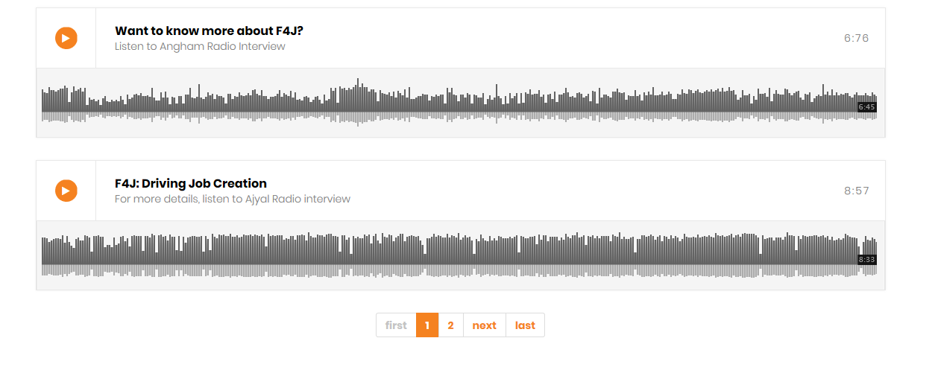
Announcements
Applications
(Please add a clickable application title, then goes to a another page with a short description and an icon Apply Now, with a link for the entire application. We have 4 application forms. One of them is ready only. We need to have these applications as on-line applications that would feed into a central database.)
Are you a women or female youth entrepreneur, working individually or with a group of women, within a family, or within a cooperative or a civil society organization? Are you interested to start or grow your business in the sheep and dairy, olive products and agri-business value chains, or in the renewable energy sector? Are you looking for support to enhance your skills and expand your opportunities? Apply now!
Entrepreneurship, Technical and Business Management Capacity Building
(A clickable title, two lines about it, then it goes to another page with the description of the program and an icon Apply Now. This application is ready and attached in the email)
Renewable Energy Capacity Building and Job Placement Opportunities
(A clickable title, two lines about it, then it goes to another page with the description of the program and an icon Apply Now. This application is not ready yet.)
Renewable Energy Innovation Fund
(A clickable title, two lines about it, then it goes to another page with the description of the program and an icon Apply Now. This application is not ready yet.)
Solar Panels Installation and Energy Saving Equipment for MSMEs
(A clickable title, two lines about it, then it goes to another page with the description of the program and an icon Apply Now. This application is This application is not ready yet.)
Procurement
(Clickable bids title)
Recruitment

Field research suggest that majority of potential women beneficiaries in the agrofood processing and sheep and goats dairy fall in the age group of above 30, while its expected that potential beneficiaries of the RE component will be mostly youth.
Individual, group, institution or government, that is not the ultimate beneficiary of the project, but that will experience a change in capacity (immediate outcome) and a change in behaviour, practices or performance (intermediate outcome) which will enable them to contribute to the achievement of a sustainable change of state (ultimate outcome) of the beneficiaries.
United Nations Country Team, Common Country Analysis, Leave No One Behind: A Perspective on Vulnerability and Structural Disadvantage, 2016, p.41.
Ministry of Social Development, National Sectoral Social Development Strategy (2017-2022), February 2017, p.28.
Ibid.
United Nations Country Team, Common Country Analysis, Leave No One Behind: A Perspective on Vulnerability and Structural Disadvantage, 2016, pp.13-17.

